CHEMICAL ENGINEERING TRANSACTIONS  VOL. , 2023 | A publication of
The Italian Association
of Chemical Engineering
Online at www.cetjournal.it

Guest Editors: David Bogle, Flavio Manenti, Piero Salatino
Copyright © 2023, AIDIC Servizi S.r.l.
ISBN 979-12-81206-04-5; ISSN 2283-9216

MSW for energy recovery - 2020-2035 scenarios for a large city
Liang Wang*, Cansu Birgen, Michaël Becidan
ª SINTEF Energy Research, Sem Sælands vei 11, NO-7034 Trondheim, Norway

corresponding author liang.wang@sintef.no
The generation rate, total amount and composition of Municipal Solid Waste (MSW) can be affected by many parameters such as population and economy growth, unfolding of Circular Economy, implementation of new regulations for material recycling and development of sorting and recycling technology. Such changes will also affect measures to treat/utilize the MSW as well as the handling of the residues, primarily ashes.
In this work, three scenarios on the future MSW sent to energy recovery for the period 2020-2035 have been developed using detailed MSW composition data from a large Scandinavian city, namely Oslo, Norway. The amount and composition of the MSW sent to energy recovery (incineration) were estimated with consideration of boundary conditions including population growth, improvement of sorting efficiency and increase of recycling rate. This work also evaluated key properties of the MSW sent to energy recovery under different scenarios, including heating value, volatile matter and carbon content and concentration of key ash-forming elements relevant to the operation of an incinerator and ash valorisation.
The results revealed that important combustion properties of MSW to incineration might be affected by increased sorting and recycling, towards lower energy and ash content with the conditions set under studied scenarios. Scenario analysis revealed that changes in the fraction of plastic has the largest effect on the carbon content and heating value of the MSW. In addition, changes in the content of ash-forming elements in the MSW were identified, which are the results of the separate collection of an ash-rich subfraction, i.e., food waste.
  - Introduction
Municipal solid waste (MSW) is a mixture of wastes generated by households and similar waste from other sources, such as commercial businesses and public institutions [1]. Waste management in the EU has been more focused on realizing a Circular Economy by promoting material recycling and reuse of waste [1]. New policies have been put in place and are now being implemented to this effect [1-3]. The pathway to a Circular Economy is influenced by multiple socio-economic and political drivers. Studies have been carried out at national and European levels to assess the effects of achieving a circular economy on the waste management sector, considering waste treatment technologies and capacities, including the treatment of unrecyclable wastes and the impact of Waste-to-Energy (WtE) [4-5]. These studies provided insights about the overall development of MSW, material and energy recovery and planning of waste treatment capacities (incineration, biogas, etc.). As an important part of the MSW treatment sector, the incineration of waste is an efficient measure to reduce the amount and volume of the MSW and handle contaminants with the benefits of generating electricity and/or heat [6]. Both the amount and composition of MSW sent to incineration have significant impacts on operation, efficiency and outputs' quality, and hence profitability. The implementation and development of separate collection and subsequent material recycling of selected fractions will impact what waste will be sent to incineration. The links and interactions between material and energy recovery value chains in an increasingly circular economy are complex and should be investigated to identify possible challenges and opportunities. However, studies to reveal such links can be difficult to conduct as the available data about MSW are often statistical values aggregated at the national level, whereas the WtE activities are usually planned and operated at the city or regional level. Hence, it is necessary to select the right geographical resolution to extract detailed and accurate data to support local waste actors and decision-makers in planning waste management. It is also important to study the long-term effects of new waste management practices promoting reduced waste generation and/or higher recycling rates. This is important and relevant to the change of amount and composition of MSW at regional and city level considering incineration capacity planning but also in regard to the role of MSW in providing district heat [6]. To do so scenarios describing different pathways towards 2030 have been described and analysed.
The three scenarios defined have different boundaries considering several key factors that affect both waste generation and management. The study focuses on the MSW collected and treated under the responsibility of the municipal entity that is responsible for household waste (and similar fractions) for the city of Oslo, Norway. The main focus of this work is to assess changes in the amount and key properties of MSW going to WtE as the circular economy unfolds under different circumstances and boundary conditions. The results from this work are meaningful to identify both challenges and opportunities for future plant operation and planning.
  - Methodology
The scenario analyses were conducted based on the MSW collected and treated by the municipal entity that is responsible for household waste (acronym REG) for the City of Oslo, Norway. At each household in the city, the plastic and food waste are gathered in purple and green bags, respectively. The unsorted residual waste from one household is gathered in ordinary plastic bags. The three types of bags are thrown into the same garbage container [7]. Ordinary plastic bags (for residual waste) are collected and delivered to an optical sorting plant (at Haraldrud). The separated food waste is sent to an anaerobic digestion plant to produce biogas and a biofertilizer. The plastic waste is delivered abroad (mainly Germany) for further sorting, separating and material recycling. After optical sorting, the remaining household waste is delivered to incineration for energy recovery at Haraldrud WtE plant. Paper waste from each household is thrown into a separate container and collected for further sorting and recycling. Other sortable wastes are usually delivered by inhabitants directly to local sorting stations, including glass, metal, E-waste, garden waste and hazardous waste. In addition, commercial & Industrial waste similar to household waste was considered in this study.
The overall methodology for scenario analysis can be described as such:
- A detailed description of the amount and compositions of MSW generated in the year 2019 is described based on waste analysis data. This is used as initial input data for implementation of the scenarios.
- Three scenarios were developed and assessed in terms of the amount and composition of MSW generated. The rationale for each scenario is described below:
  - Current Road scenario
This scenario is considered as ''Business as usual''. Yearly historical changes of each waste fraction per capita were calculated from available statistical data for the years 2015 to 2019 and their averages were used as the input to the scenario implementation [7-8]. A population change (+0.2%) per year is assumed based on historical trend as well. Table 1 lists yearly changes in waste fractions per person used for implementing Current Road scenario. Subfractions had the same annual rate of change as their respective waste fractions except reading material subfraction (paper waste) set at -7% and metal packaging (metal) as +2%, both based on recent historical developments.
Table 1: Yearly changes in waste fractions per person used for assessing Current Road & Circular Road scenarios
Waste fraction | Residual | Food | Plastic | Paper | Glass | Metal | E-waste | Garden | Dangerous |  | Waste wood | Construction | other
Yearly change | -2% | +4% | +5% | -4% | +2% | +4% | -3% | -4% | +1% |  | -1% | 0% | 0%

  - Circular Road scenario
This scenario focuses on assessing the effects of improved sorting on the different waste fractions. For this scenario, the total amount of MSW and waste fractions generated each year are kept the same as in the current road scenario. However, assuming an improvement in sorting behavior, an increased fraction of each recyclable waste fraction found in the residual waste container, due to wrong or improper sorting, are now "moved" to proper separate collection. For example, every year, 10% of plastic found in the residual waste container is thrown into plastic waste container instead. A 10% improvement in sorting based on the previous year is assumed for all recyclable fractions.
  - Frugal Road scenario
The Frugal Road scenario focuses on the impact of waste reduction on the amount and composition of waste to be recycled and incinerated. The following assumptions were made to implement Frugal Road scenario. 1) there are no wrongly sorted waste fractions in any of the waste containers, except plastic bags for keeping wastes. 2) no “edible food waste” and “reading material and other paper” in containers dedicated to them. 3) yearly changes in other waste fractions are the same as in the Current Road and Circular Road scenario, except when the rate of change was positive. in that case, the change was set to 0%.
- For each scenario, given the specific conditions, the total amounts of MSW delivered to incineration from the year 2019 to 2035 were calculated. In addition, the details concerning 12 main subfractions in the MSW were also obtained and discussed.
- Estimation of key combustion properties of MSW were assessed, including ash. An excel-based calculation tool has been developed to carry out these calculations. The excel based calculation tool does not claim to be a comprehensive model, but to estimate changing trends and relative changes of amount and properties of MSW. The data obtained from the analysis of the main subfractions of MSW reported by Götze et al [8] were used for calculating key properties of the MSW relevant to energy recovery via incineration.
  - Result
    - Amount and composition of MSW sent to incineration with energy recovery
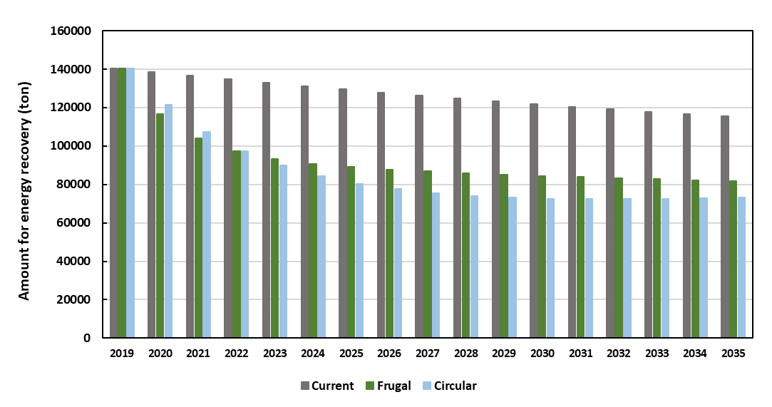
As shown in Fig 1, for all scenarios, the amount of waste sent to incineration will decrease over the studied time frame from year 2019 to 2035 but not to the same extent. For the Current Road and Frugal Road scenarios, the calculated amounts of MSW for incineration are evidently lower than that obtained from the current road scenario given the framework conditions. A line corresponding to 100 000 tons of MSW for energy recovery is also included in the Fig 1, which represents the nominal capacity of the WtE Haraldrud plant. For the Current Road scenario, the calculated amounts of residual waste to incineration are always over 100 000 ton/year line. On the other hand, for both the Frugal and Circular Road scenarios, the amounts of waste for incineration are stabilized after the year 2027, reaching about 81 and 71 ktons/year in 2035. Fig 2. shows the composition of the waste being incinerated. The MSW to WtE (2019 data) contains significant proportion of food waste (26.7%), wood waste (11.6%), plastic waste (8.6%) and paper waste (7.1%). In addition, there is about 30.9% of MSW that does not belong to any category shown in Fig 1(a), which is categorized as residual waste. The residual waste is a complex, heterogeneous and ever-changing mixture containing a wide variety of items and materials. For the Current Road scenario, the composition of MSW to WtE in 2035 is rather similar to that of the year 2019.
Figure 1. MSW for to WtE for year 2020-2035 under the three scenarios.

For the three scenarios, the amounts of individual waste fractions for material recycling (data not shown) and energy recovery were calculated. The proportion of each waste fraction in the total MSW to energy recovery was also determined. Fig 2 shows the relative composition of MSW received for energy recovery. Fig 2(a) displays the compositions of MSW for energy recovery in the year 2019, used as the reference year. Figures 2 (b), (c) and (d) show the composition of MSW going to WtE under the three scenarios in 2035. For the Current Road scenario, in comparison to the composition of MSW collected in 2019, the proportion of paper, plastic and food waste were reduced from 7.1%, 8.6% and 26.7% to 6.4%, 8.0% and 23.9% in 2035, respectively. For the Frugal Road and Circular Road scenarios, there are larger differences regarding the main waste fractions. The proportion of food waste in the MSW for energy recovery is only 13.4% in the year 2025, which is about 44% lower than the value in the same year predicted under the Current Road scenario. It is mainly related to the reduced generation of edible food waste. For the Circular Road scenario, the decreases of paper, plastic and food wastes in the MSW for energy recovery are more evident. Compared to the values in 2019, the proportion of these three fractions decrease by 83%, 59% and 93%, respectively. Fig 1 and 2 indicate, under the defined scenarios, that the implementation of different Circular Economy principles,i.e., better sorting and waste reduction, can produce significant impacts on the composition of MSW for energy recovery, which can consequently affect the operation of WtE plants including emissions and residues.

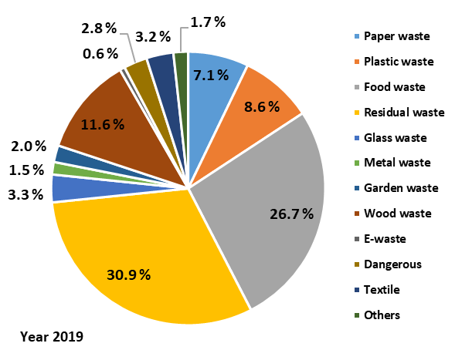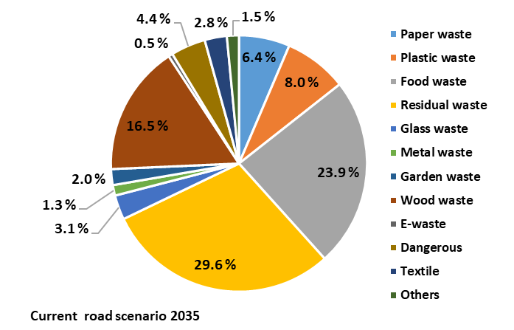
a
b
c
d
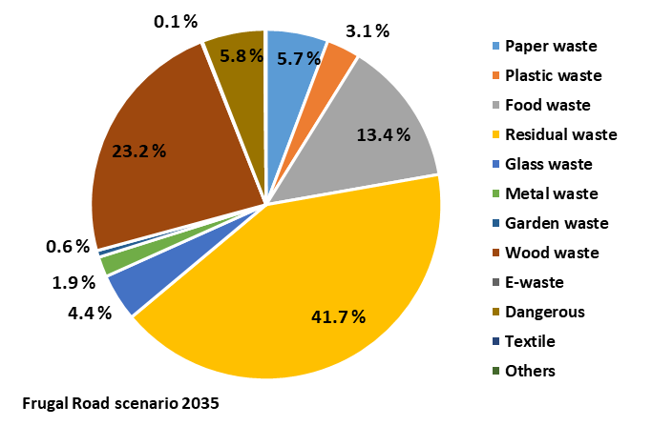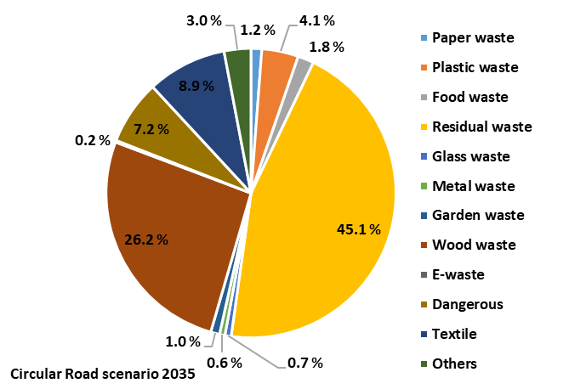
Figure 2. Composition of MSW to WtE in2019 (a) and in 2035 under different scenarios (b,c,d)
    - Key properties of MSW to incineration for the different scenarios
Fig 3. (a) shows the proportions of the main waste fractions in the year 2035 for the three scenarios. With increased sorting of recyclable fractions, the amount of paper, plastic, food (and glass) waste in the MSW for energy recovery are much smaller These three wastes are main combustible fractions in the MSW. Therefore, their decreases can affect the properties of MSW as a solid fuel used to generate heat and/or power. Fig (3b) and (3c) display that both the carbon and volatile matter contents of the MSW for energy recovery decrease gradually from the year 2020 to 2035 for all scenarios. Under the Circular Road scenario, the decreasing trends for volatile matter and carbon content are more significant. It is mainly related to the disappearance of paper, plastic and food waste. As reported by Götze et al [8], the volatile matter content and carbon content of paper, plastic and food wastes are in the range of 90-98% and 44-82%, respectively. Changes of volatile matter and carbon content influence heating value of the MSW for energy recovery consequently, which decrease under the three scenarios. Under the Current Road scenario, the heating values of MSW for energy recovery are slightly higher than the values predicted for the other two scenarios. It is probably due to higher contents of paper, plastic and food waste in the MSW under the Current Road scenarios. These three fractions are combustible and are also dominant in weight, hence the general properties of the MSW for energy recovery are more sensitive to the change of these waste fractions. In WtE plants, the heat generated through the incineration of MSW is used for heat and/or production. Therefore, together with the gate fee, the heating value of MSW is one of the main factors affecting output and profitability of a WtE plant.
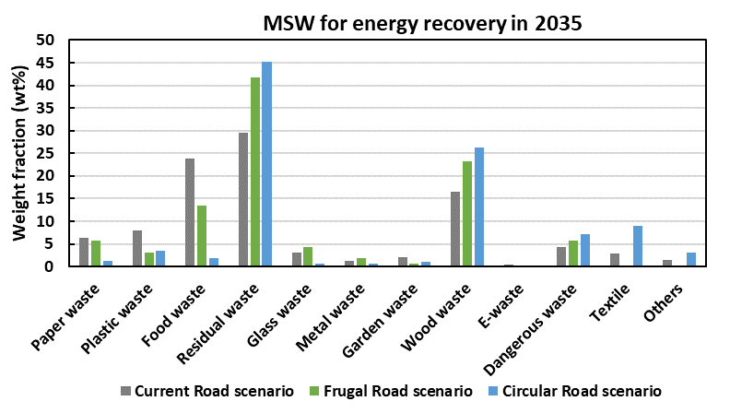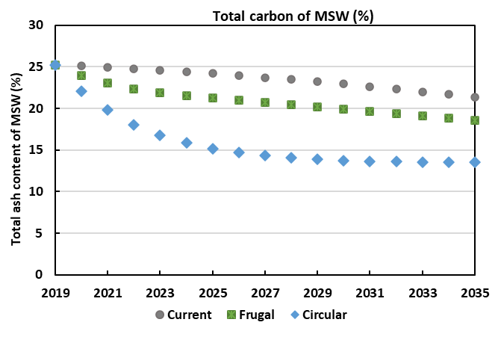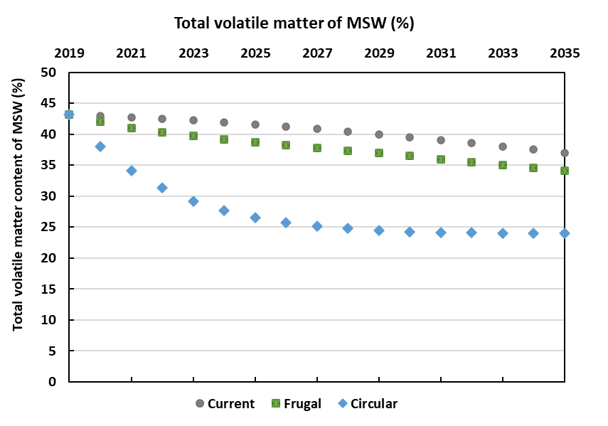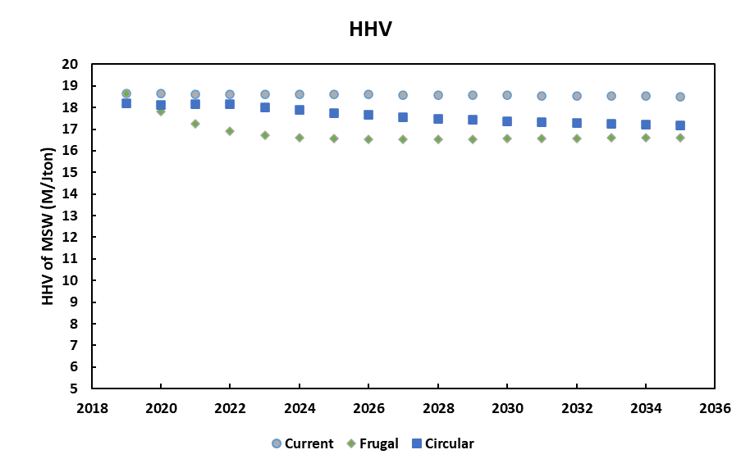
a
b
c
d

Figure 3. Proportion of waste fractions (a) in 2035 under three studied scenarios and change of general properties of MSW for energy recovery (b) volatile matter content, (c) carbon content and (d) Higher Heating Value (HHV)
    - Ash forming elements
Fig 4(a) shows the content of ash in the MSW for energy recovery, which has a clear decreasing trend for all three scenarios. As shown in Fig (2), plastic waste, paper waste, food waste and wood waste and residual waste are the five dominant fractions in the MSW for energy recovery. Each of them is a mixture of a variety of sub-categories. Some sub-categories of these five dominant subfractions have high contents of ash-forming matters.
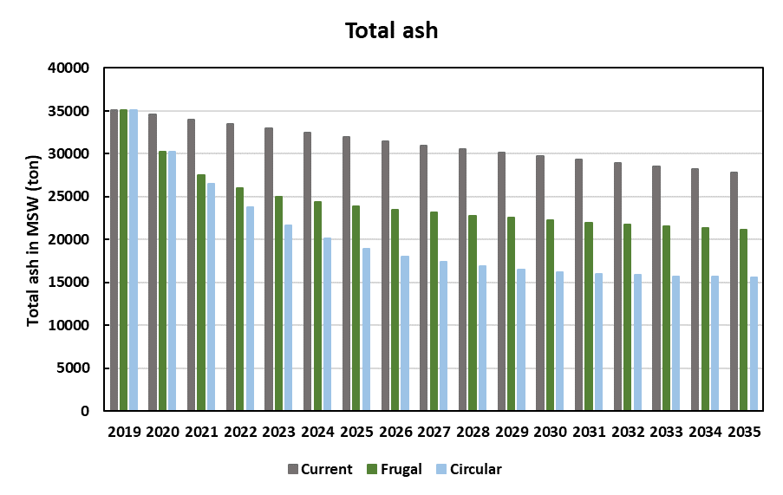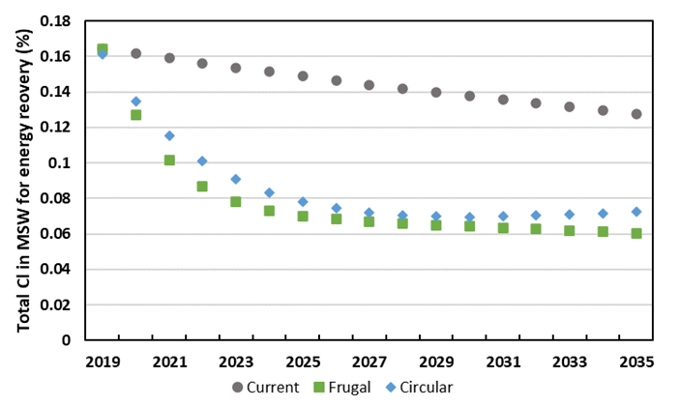
(b)
(a)
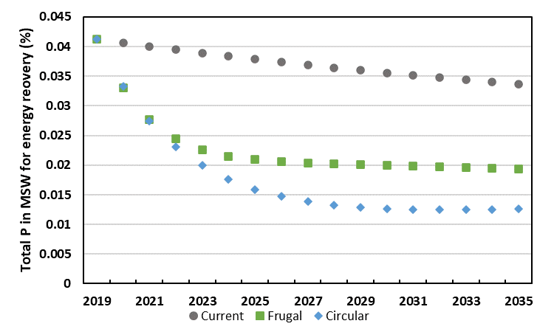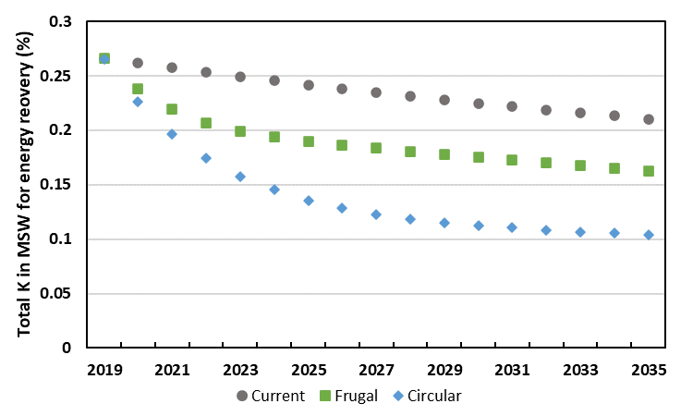
Figure 4. Content of ash, Cl, P and K in the MSW for energy recovery.

For example, paper waste is made of sub-categories, cardboard and paperboard, paper and cardboard composite, magazines and newsprint, which have ash contents in the range of 8.12-24.03% [8]. The food waste, including animal-derived food waste, vegetable waste and tissue paper, generally has a high content of ash in the range of 6.68-24.04% on dry basis [8]. On the other hand, wood waste, has a rather low ash content of about 1.5% [8]. Therefore, decrease in paper waste, plastic waste and food waste is the main cause of the gradual reduction of ash in the MSW predicted under three studied scenarios. Composition change of waste fractions in the MSW for energy recovery can also impact the proportion of specific inorganic elements as shown in Figure 4(b)-(d). Evident concentration reduction of Cl in MSW for energy recovery is shown in Figure 4(b). This is mainly related to the considerable decrease of plastic and food waste as set under the Frugal Road and Circular Road scenarios. For the P and K, food waste is the main contributor to these two inorganic elements in the MSW. Under the Circular Road scenario, the reduction of food waste is more significant than those predicted under the two other scenarios. It partially explains the lower contents of K and P in the MSW for energy production in this scenario. Content change of inorganic elements in the input MSW for WtE can affect the conversion behaviours of the MSW under thermal conversion, including the generation of ash residues and their further disposal and valorisation. For example, a decrease of Cl in the MSW can be beneficial to mitigate ash-related operational problems, i.e., deposition and corrosion and the concentration of HCl in the flue gas. On the other hand, the concentration of possibly valuable elements (i.e., P) may decrease as well, affecting the valorisation potential of the ash residues, an important aspect in a circular economy.
  - Conclusions
In this work, we defined three MSW scenarios for a large city for 2020-2035 with plausible frameworks setting key parameters (i.e., population, waste generation, waste sorting and recycling rate) and evaluated the consequences of circular economy principles on the amount and properties of MSW for energy recovery. Results from the current work indicated that: (1) the evolution of both population (the number of inhabitants), consumption (i.e., waste generation rate per inhabitant) and sorting behaviours have large impacts on the amount and composition of the MSW for energy recovery, (2) increased sorting of MSW at the household level can have significant consequences on the amount and composition of MSW generated for energy recovery. It is very clear for the largest recyclable fractions found in MSW such as paper, plastic and food waste, (3) key combustion properties of MSW to WtE are generally towards lower ash and energy content under the three scenarios, how this might impact plant operation should be studied further, (4) ash concentration (as well as the concentrations ofcertain inorganic elements) gradually decreases from the year 2020 to 2035 under three scenarios, but to different extents. The developed calculation tool for scenario analysis is Excel-based and can be used to evaluate '' what-if scenarios''. Combining historical development and current detailed datas together with new (circular economy) principles, goals and/or behaviours, general trends in terms of the total amount and detailed composition of MSW for energy recovery can be obtained. This is valuable to support future waste management planning.
Acknowledgments
This work is part of the Waste-to-Energy and Municipal Solid Waste management systems in Circular Economy (CircWtE) project co-funded by industry and public partners and the Research Council of Norway under the EnergiX program (CircWtE - 319795). The authors would like to thank REG Oslo for their help concerning data collection.

References
[1] Europe Commission. 2020. Circular Economy Action Plan- A new Circular Economy Action Plan for a Cleaner and More Competitive Europe. https://ec.europa.eu/environment/circular-economy/pdf/new_circular_economy_action_plan.pdf
[2] Europe Commission. 2018. European Parliament and Council Directive 94/62/EC of 20 December 1994 on packaging and packaging waste.
[3] CEWEP. 2018. Calculation Tool for potential impacts on waste amounts for thermal treatment. https://www.cewep.eu/wp-content/uploads/2019/05/Peer-Review_waste-treatment-need-in-2035.pdf
[4] Jedelhauser M. Roth S. 2020. The future of waste incineration in a modern circular economy. Nature and Biodiversity Conservation Union.
[5] L. Wang and M. Becidan 2021 IOP Conf. Ser.: Earth Environ. Sci. 691 012006
[6] Household waste, by material and treatment (M) 2015 - 2019. Statistics Norway. https://www.ssb.no/en/statbank/table/12313/
[7] Oslo kommune Energigjenvinningsetaten. Årsberetning 2019.
[8] R. Götze, K. Pivnenko, A. Boldrin, C. Scheutz, T. Fruergaard Astrup, 2016. Physico-chemical characterisation of material fractions in residual and source-segregated household waste in Denmark, Waste Management, 54, 13-26.

